**Ideation Phase**

**Brainstorm & Idea Prioritization Template**

|  |  |
| --- | --- |
| Date | 06 May 2023 |
| Team ID | NM2023TNID2223 |
| Project Name | Industrial worker safety and health monitoring  System based on iot. |
| Maximum Marks | 4 Marks |

**Step-1: Team Gathering, Collaboration and Select the Problem Statement**

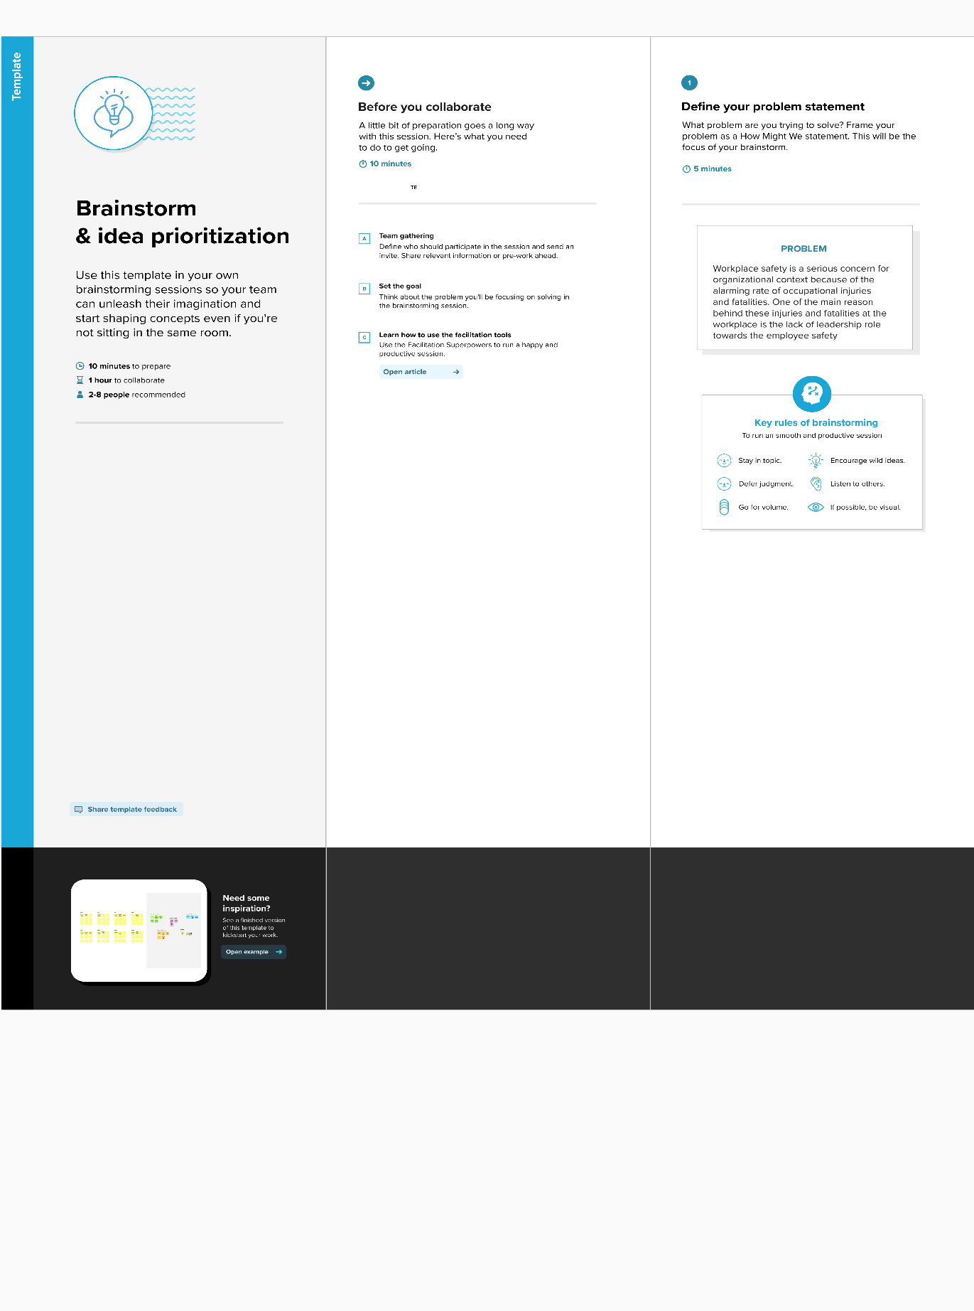

**Step-2: Brainstorm, Idea Listing and Grouping**

**Step-3: Idea Prioritization**

